# WEEK _5

# Task 1 : Working with Docker CLI Commands:

# Basic Docker Commands

**1.docker –version**

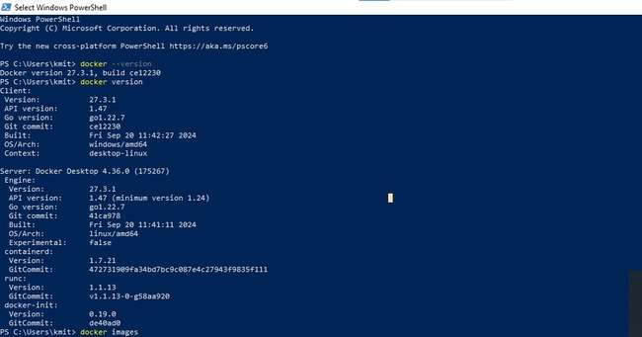

**2.docker images**

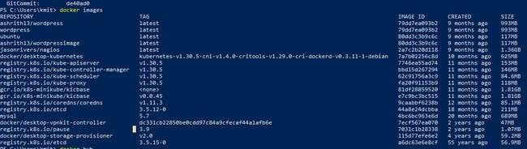

**3.docker ps**

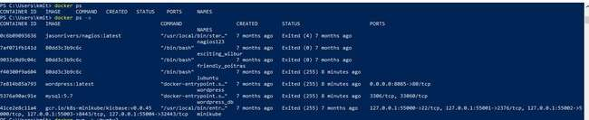

**4.ls**

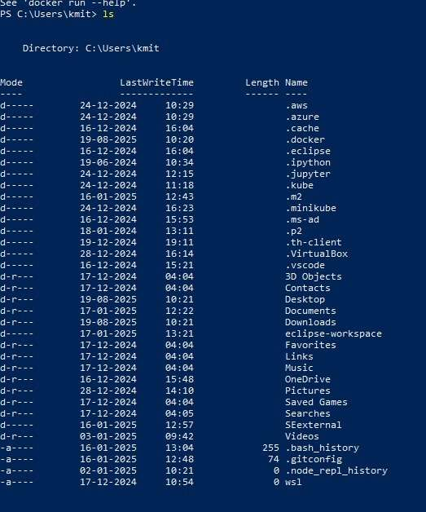

# Docker CLI Commands with redis

**Step 1: Pull the redis Image**

docker pull redis

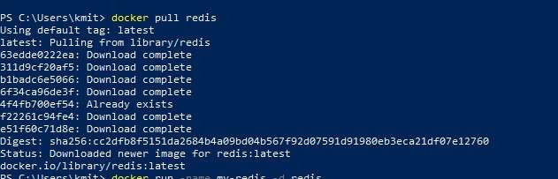

**Step 2: Run a Redis Container**

docker run --name my-redis -d redis



**Step 3: Check Running Containers**

docker ps



**Step 4: Access Redis**

docker exec -it my-redis redis-cli

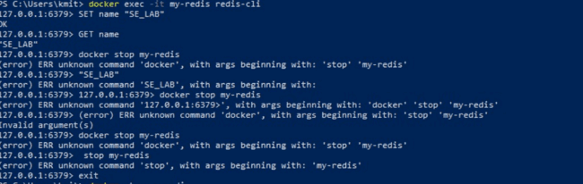

**Step 5: Stop the Redis Container**

docker stop my-redis

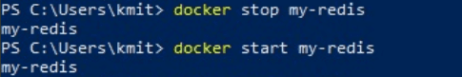

**Step 6: Restart the Redis Container**

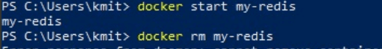

docker start my-redis

**Step 7: Remove the Redis Container**

docker rm my-redis

**Step 8: Remove the Redis Image**

docker rmi redis

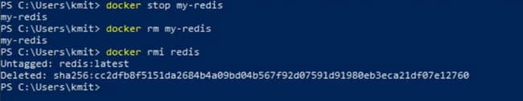

# Task 2: Working with Docker file

**Step 1: Set Up Your Folder**

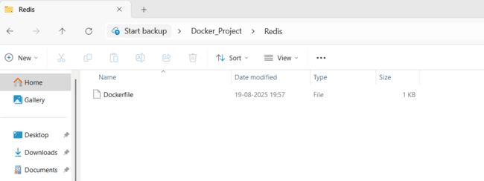

**Step 2: Write the Docker file**

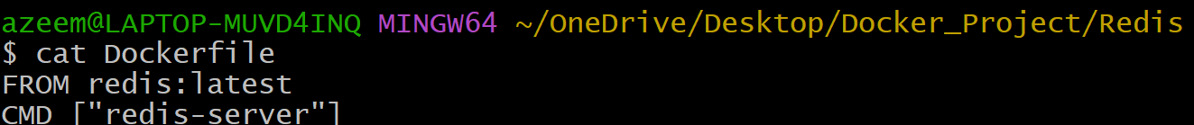

**Docker Commands (Step-by-step):**

1. **docker build -t redisnew**

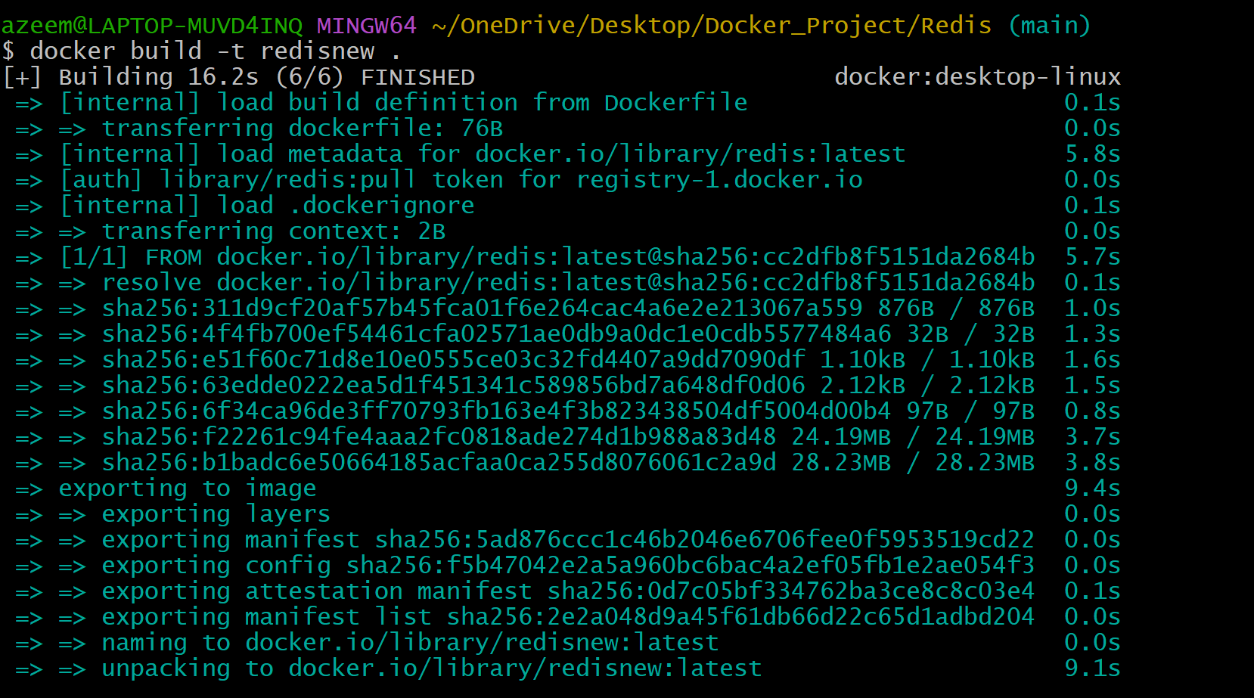

**2. docker run --name myredisnew -d redisnew**

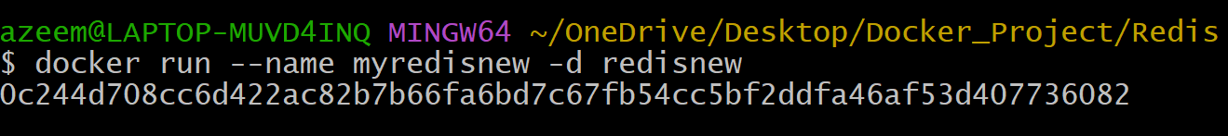

**3. docker ps**

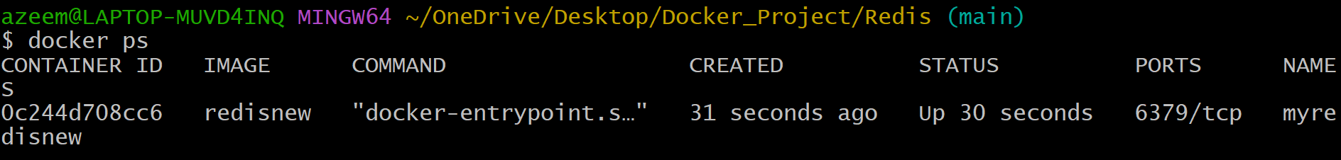

**4. docker stop myredisnew**

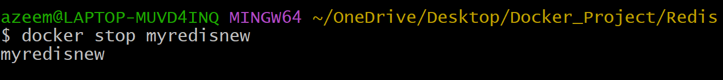

**5. docker login**

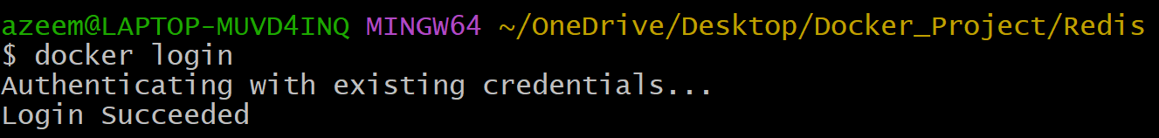

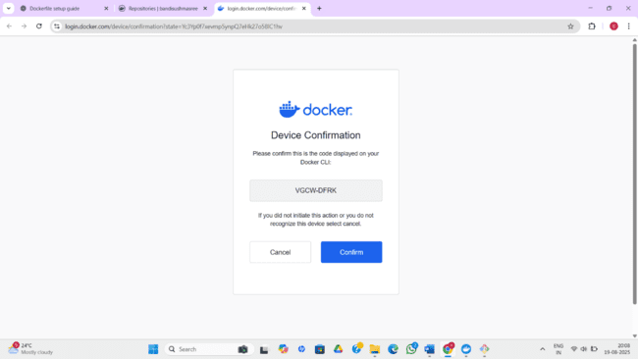

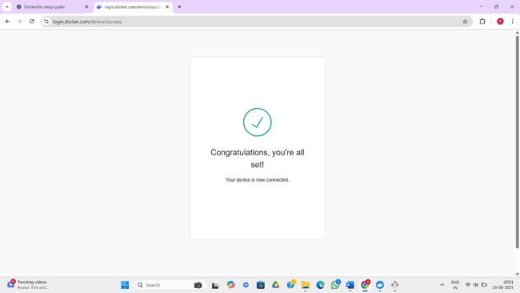

**6. docker ps -a**

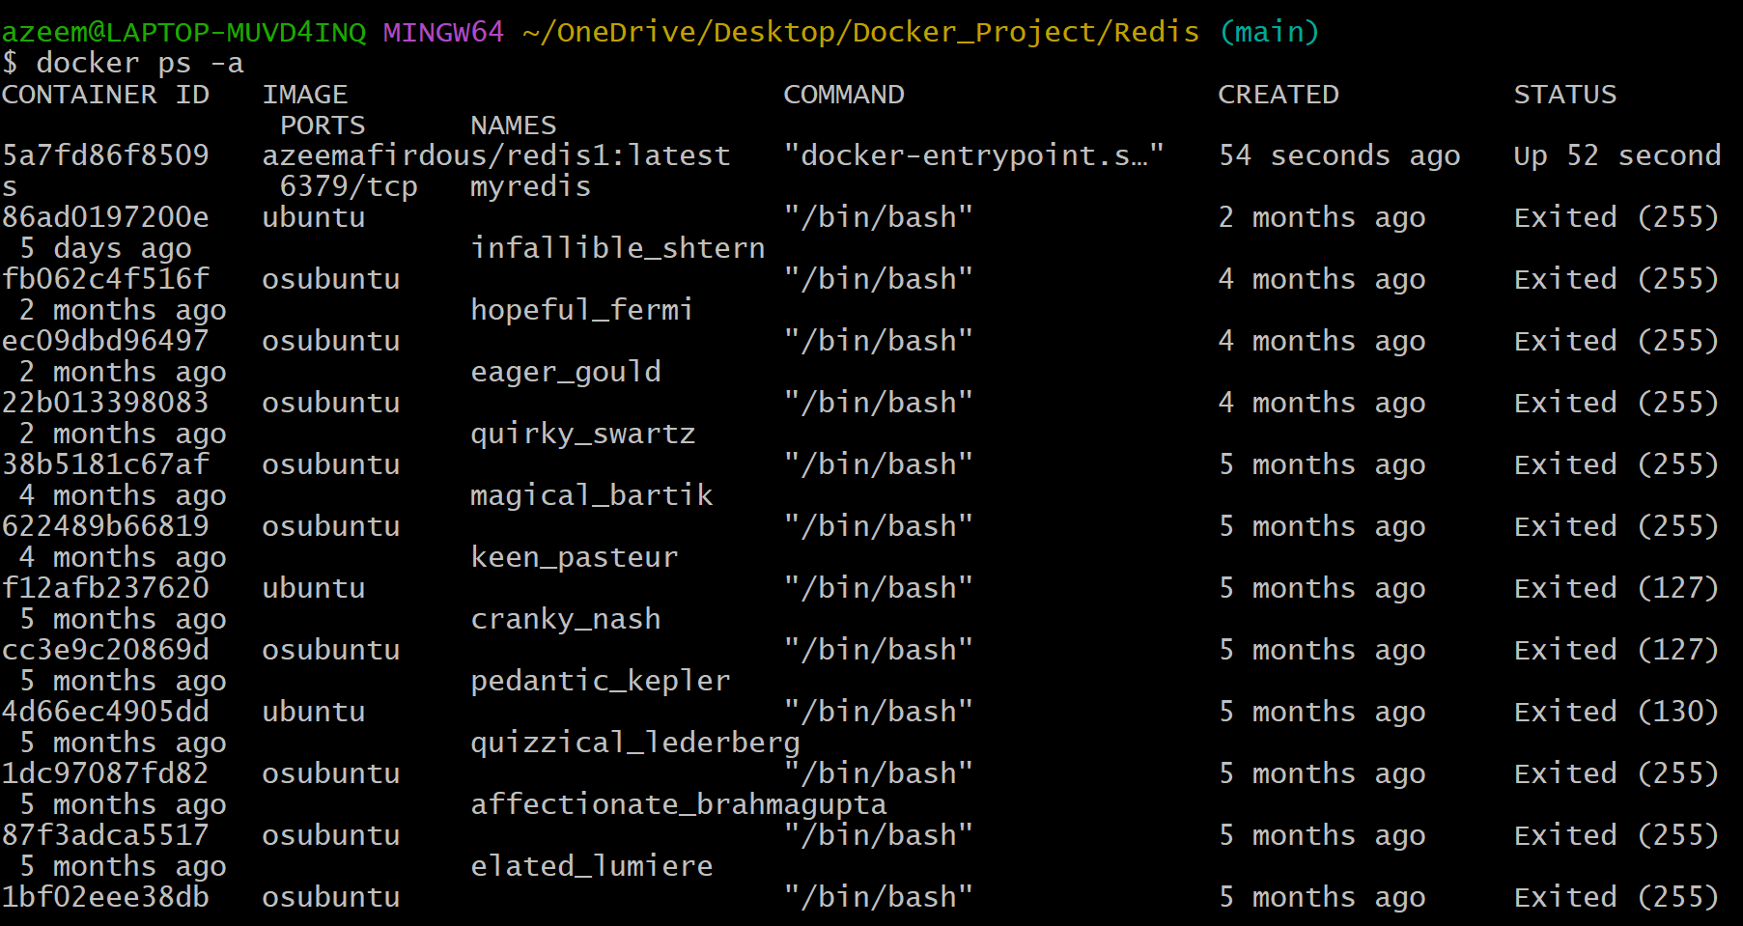

**7. docker commit**

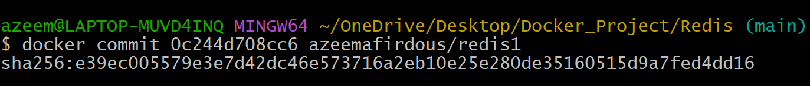

**8. docker images**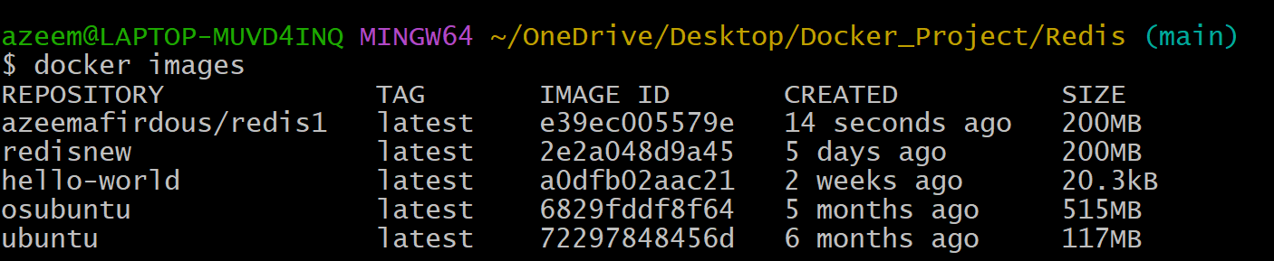

**9. docker push**

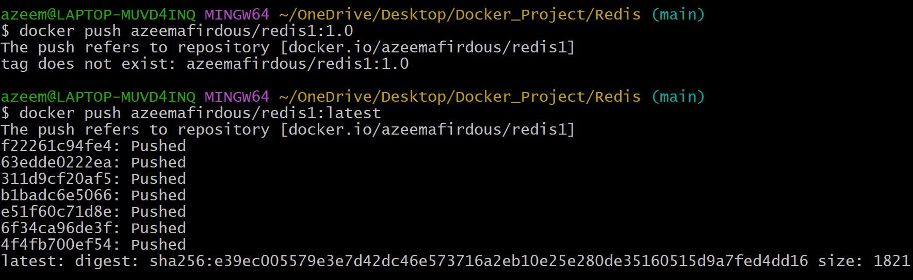

**10. docker rm**



**11.** **docker rmi**

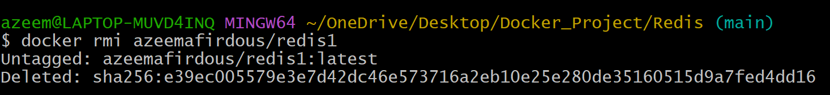

**12. docker ps -a**

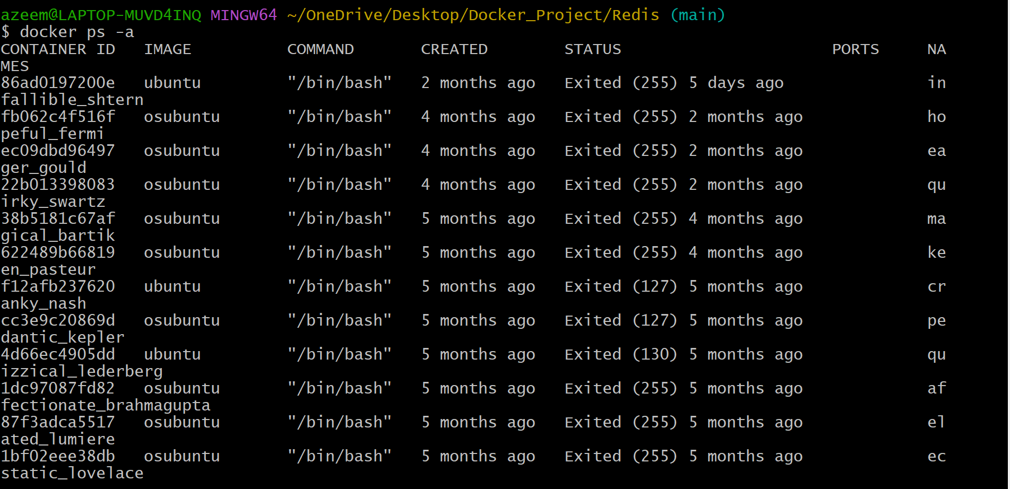

**13. docker logout**



**14. docker pull**

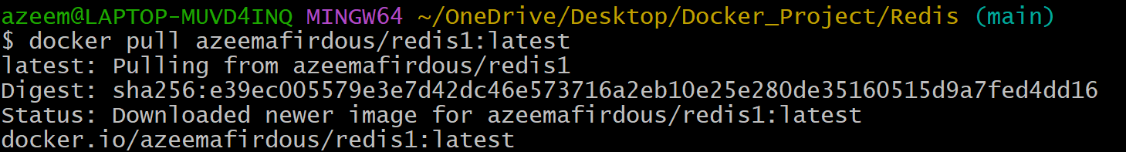

**15. docker run --name myredis -d**



**16. docker exec -it myredis redis-cli**

**17. SET name**

**18. GET name**

**19. exit**

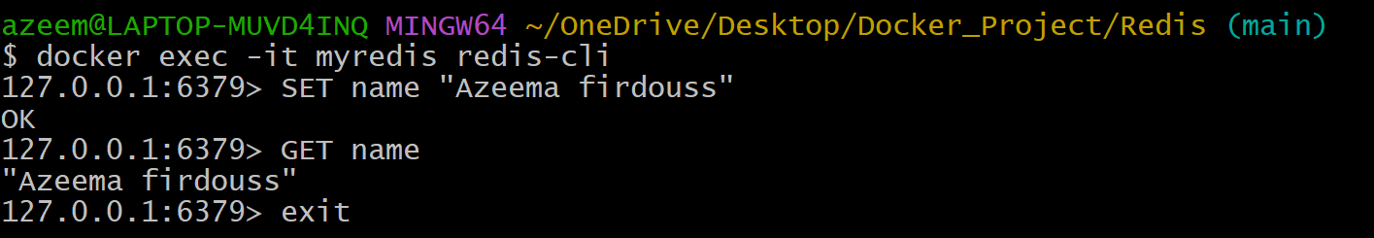

**20. docker ps -a**

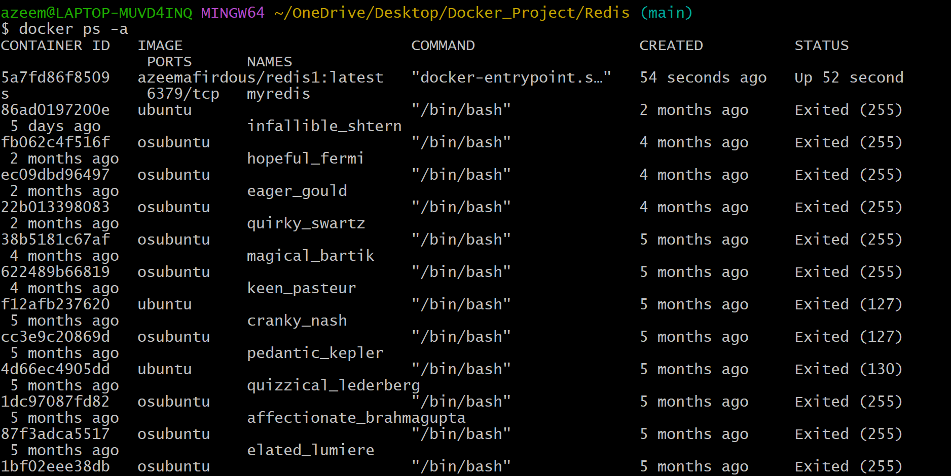

**21. docker stop myredis**



**22. docker rm**

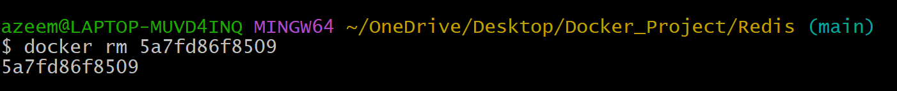

**23. docker images**

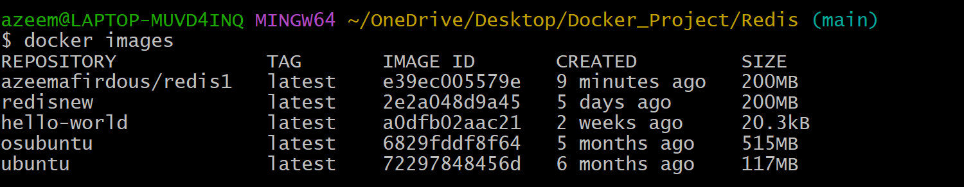

**24. docker rmi**

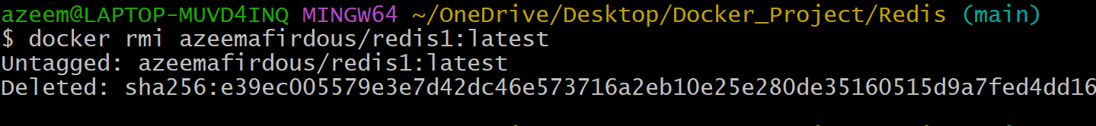

**25. Remove Login Credentials (Optional)**



# Task 3: **Scenario based Questions**

**1.Your application is running inside Docker, but you’re not sure if the container is active.  
Which command helps you check running containers?**

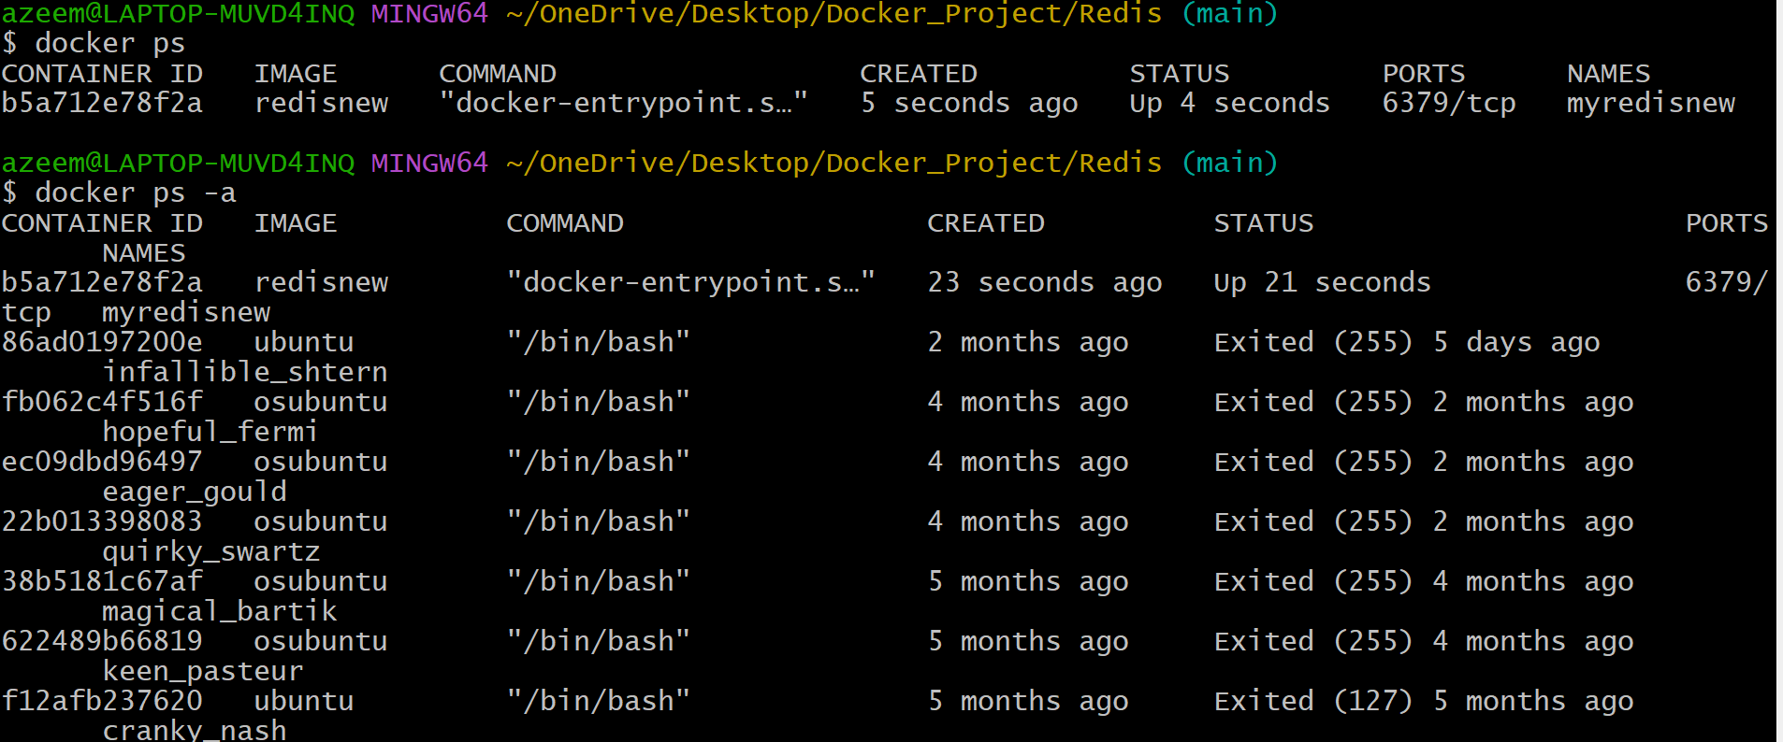

1. **You notice one of your containers is consuming high CPU and want to stop it.  
   How do you stop a running container named web_app?**

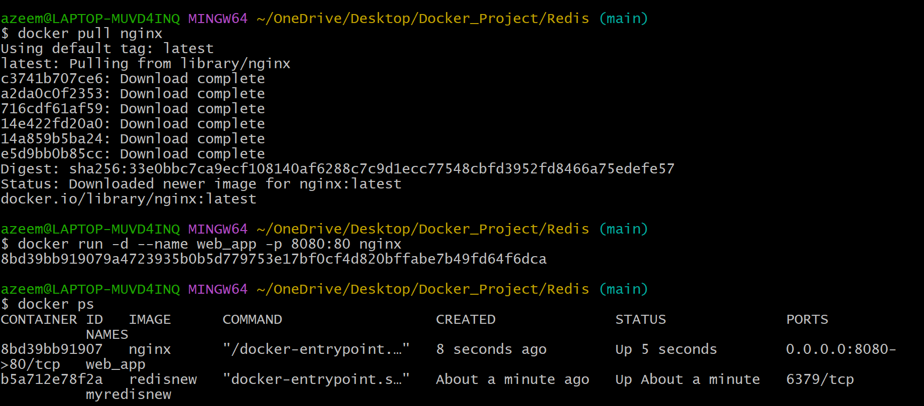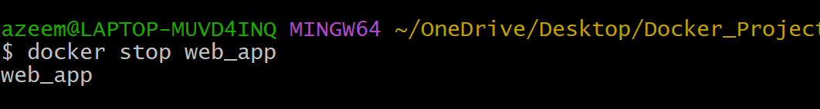

1. **You’ve written a Dockerfile in your project directory and want to build an image named myapi.**

**What Docker CLI command do you use?**

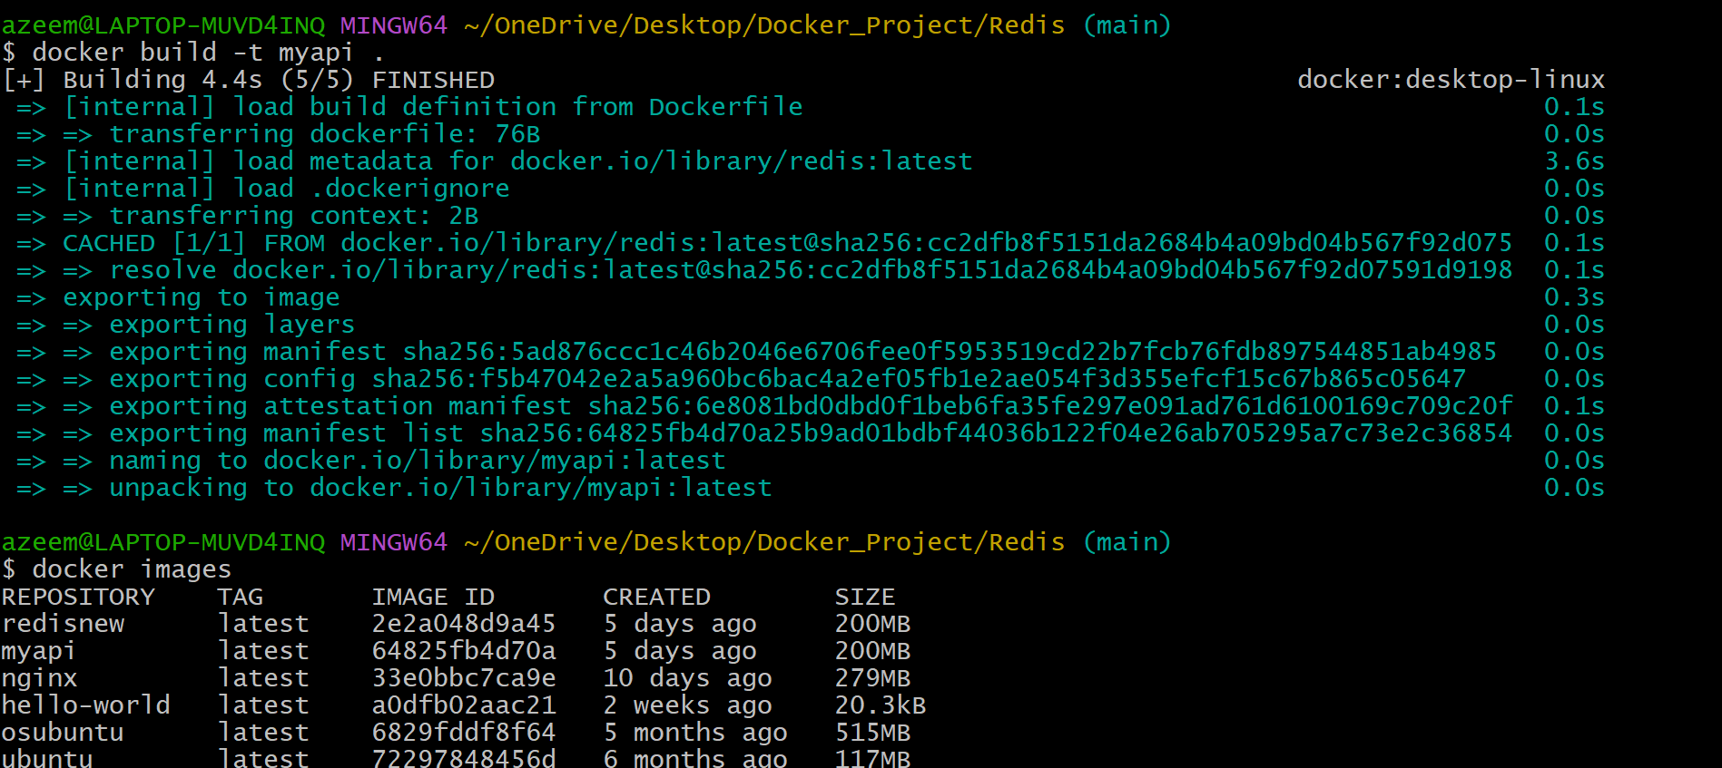

1. **You want to run your web_app container and expose its internal port 5000 on host port 8080.  
   Which command should you use?**

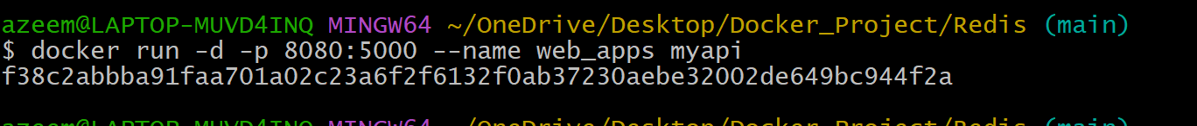

1. **Your container is running, but you want to go inside and debug it using a shell. What CLI command helps you enter the container’s shell?**



1. **You’ve built a few test images and want to delete one called old_api. How would you do this?**

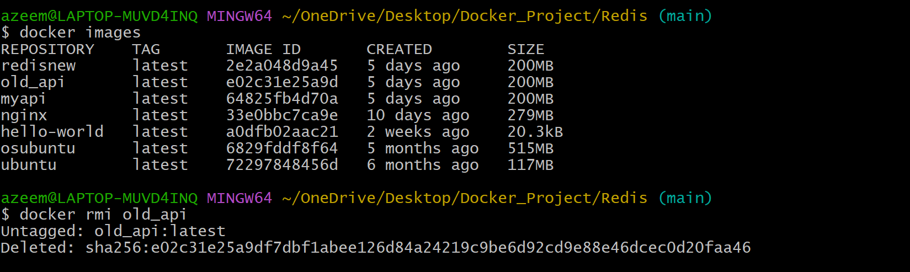

1. **Your app crashed in the container. You need to check the logs. How do you check this?**

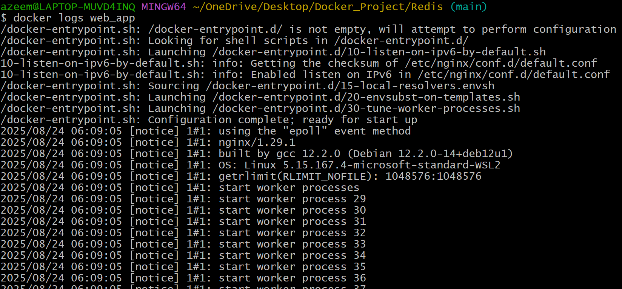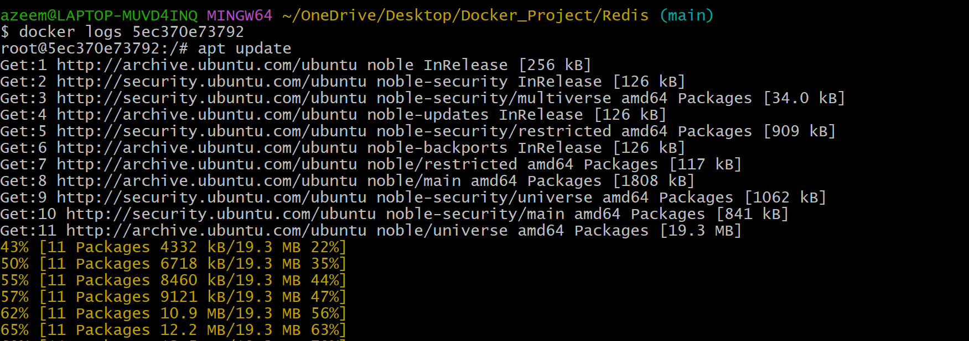

1. **You want to start a container and let it run in the background. Which command should you use?**



1. **You're not sure which container is using port 3000. How do you check?**

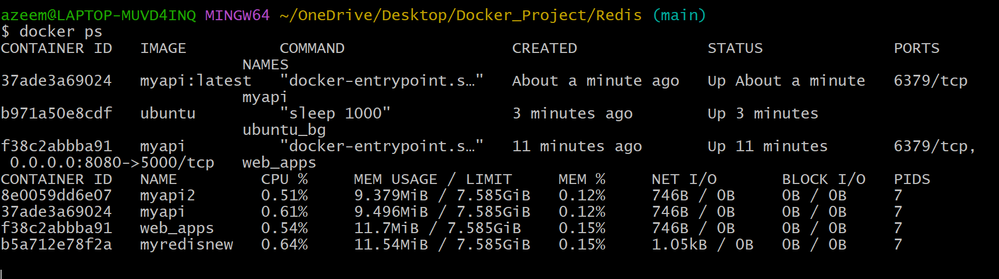

1. **You built an image but forgot to tag it. How do you tag it now?**

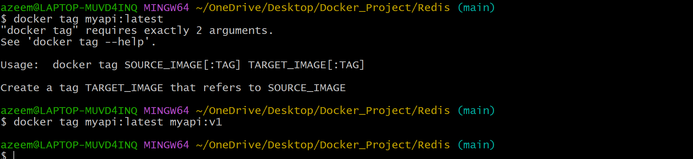

1. **You want to export an image to a .tar file for offline transfer. How do you export it?**

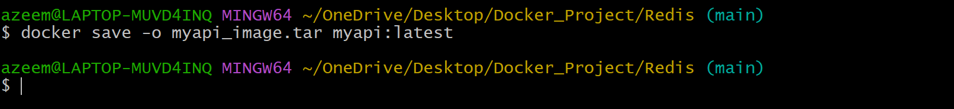

1. **You want to restart a container automatically if it crashes. What Docker CLI command do you use?**



1. **You want to see how much CPU/RAM each container uses. What Docker CLI command do you use? How to Control or Limit RAM in Docker? How to Measure Actual Memory Usage?**

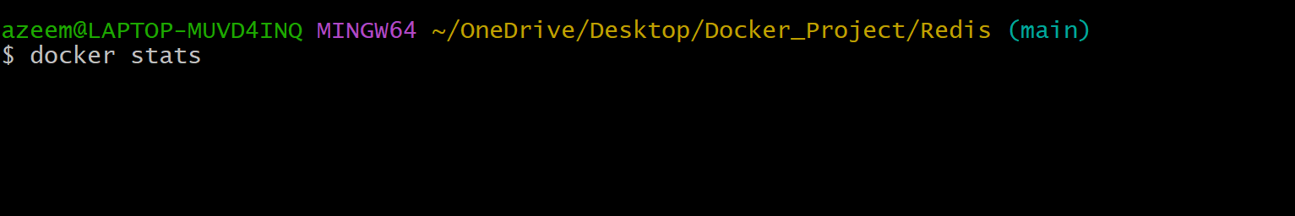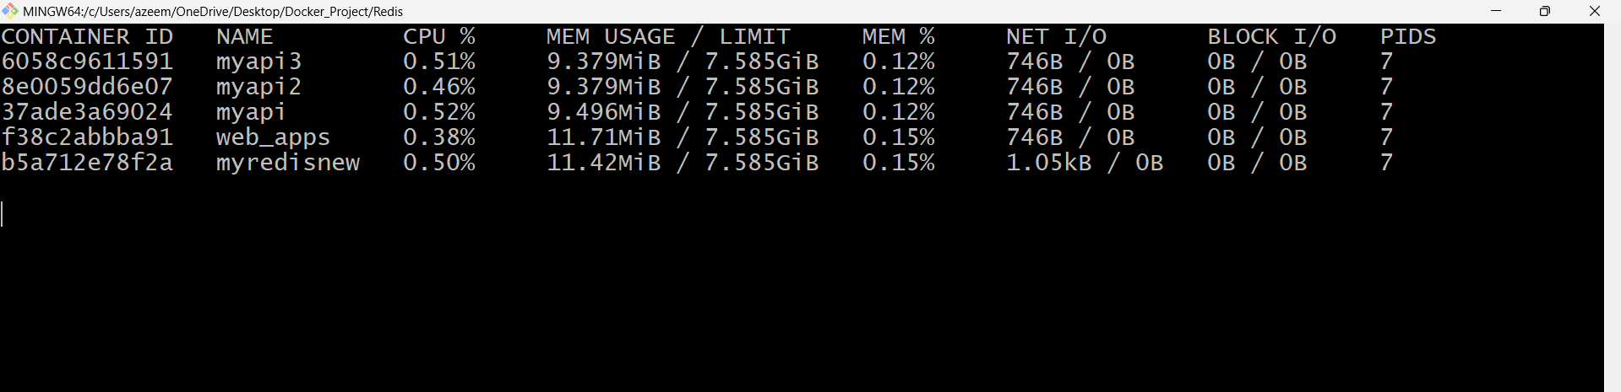

1. **You want your container to run a shell command before starting the app. What do you include in docker file?**

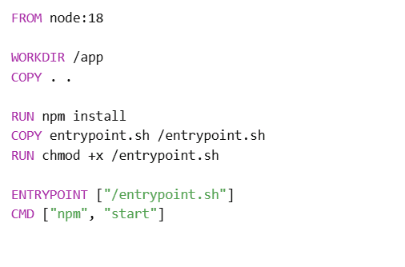

**15. You want to create a custom Nginx image with your static files. What do you do?**

